Sentinel and the Professional-Standard Readiness Gap in Privacy-Preserving Edge-Al Mental-Health Anomaly Detection

Abstract
Sentinel is presented as a privacy-preserving edge-Al architecture for proactive mental-health anomaly detection, but the available evidence does not establish its effectiveness, safety, regulatory conformity, or production readiness. No detection estimates, confidence intervals, error rates, privacy guarantees, validation results, or operational performance metrics are reported. The architecture may reduce wholesale transfer of sensitive mental-health data by processing information at or near its source, yet the specific edge devices, cloud components, data flows, privacy mechanisms, and threat assumptions remain unspecified (Anant, n.d.). This gap is important because mental-health anomaly detection combines highly sensitive data with potentially consequential alerts, requiring coordinated attention to privacy, cybersecurity, clinical validity, human oversight, interoperability, and professional standards. The detection scope is also undefined: the target conditions, behavioral or physiological signals, anomaly definitions, population, alert thresholds, and intended clinical or wellness setting are not identified. No clinical, security, machine-learning, software-engineering, interoperability, or regulatory standards are mentioned. Consequently, Sentinel's principal industry and professional-standard limitations concern not a demonstrated technical failure, but the absence of evidence needed to determine whether the system is safe, effective, governable, and deployable. Future work requires explicit architecture specifications, empirical validation in representative populations, formal privacy and security analysis, clinically meaningful outcome definitions, alert-governance procedures, lifecycle monitoring, and documented standards alignment.
Keywords: privacy, preserving, edge, mental, health, anomaly, detection, architecture

1. Introduction
Mental-health monitoring increasingly intersects with artificial intelligence, mobile sensing, and distributed computing. These technologies may support earlier recognition of behavioral change by analyzing information close to where it is generated. In mental-health applications, however, the potential benefits of proactive detection are accompanied by unusually high privacy, safety, and governance demands. Behavioral and physiological data can reveal intimate characteristics even when they are not explicitly labeled as clinical information. An incorrect alert may create anxiety, stigma, inappropriate intervention, or unnecessary clinical workload, while a missed anomaly may delay support. Accordingly, a system intended for proactive mental-health anomaly detection must be assessed not only as a machine-learning model, but also as a socio-technical and potentially regulated health technology.
Sentinel is described as a privacy-preserving edge-Al architecture for proactive mental-health anomaly detection. Edge-Al refers here to processing performed at or near the data source rather than transferring all raw information to a centralized service. This design orientation may reduce dependence on centralized data movement, but local processing alone does not establish privacy. Privacy protection also depends on the handling of outputs, model updates, device access, cloud coordination, consent, retention, and the possibility that sensitive information can be reconstructed or inferred from transmitted results.
The available description identifies Sentinel's broad architectural intent but leaves central implementation and evaluation questions unresolved. It does not specify the devices, data modalities, cloud topology, target population, anomaly definitions, detection thresholds, evaluation datasets, baseline systems, or validation setting. It also does not identify clinical, security, software, interoperability, regulatory, or responsible-artificial-intelligence standards. These omissions prevent a determination of whether the architecture satisfies the expectations normally associated with safety-critical health technologies or professional deployment.
This review therefore examines Sentinel specifically as an industry- and professionally oriented architecture. It synthesizes what is known about its edge-Al and privacy model, then identifies the evidentiary, technical, clinical, operational, cybersecurity, and standards-related limitations that must be resolved before production or clinically consequential use can be assessed.
2. Methods
2.1 Search Strategy
Papers were sourced from the user's personal reference manager library. The review analyzed 1 papers that the user had previously collected and organized in their reference management system.
2.2 Study Selection
From the reference manager library, 1 papers were initially considered. After duplicate removal and relevance-based filtering, 1 records were screened against eligibility criteria. Of these, O papers were excluded, resulting in 1 papers included in the final synthesis.

PRISMA Flow Diagram
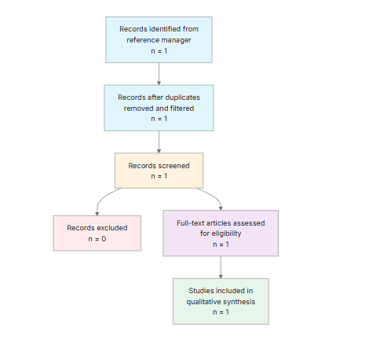
Eligibility criteria included:
- Scope: Does the paper describe a privacy-preserving edge-Al system for proactive mental health anomaly detection?
- Evaluation: Does the paper report any experimental, simulated, or real-world validation of the proposed system?
- Privacy: Does the paper explicitly address privacy or data-protection considerations in the system design?
- Clinical Relevance: Does the paper target a mental health or behavioral health use case with potential clinical relevance?
- Production Concerns: Does the paper discuss deployment, scalability, monitoring, integration, or operational concerns relevant to industry use?
- Standards Alignment: Does the paper mention standards, regulations, best practices, or compliance considerations?
- Limitations: Does the paper explicitly discuss limitations, assumptions, or unresolved risks?
Note on included studies: Sentinel was retained despite no reported experimental, simulated, or real-
world validation, no identified standards alignment, and no explicit limitations section because it provides the directly relevant architectural subject for assessing industry and professional-standard problems in privacy-preserving edge-Al mental-health anomaly detection (Anant, n.d.).
2.3 Data Extraction and Synthesis
Data extraction focused on the following variables:
- Architecture: Extract the core system architecture, deployment setting, and edge/cloud components of Sentinel.
- Privacy Model: Extract the privacy-preserving approach, data handling, consent, encryption, federated/on-device processing, and any privacy assumptions.
- Detection Scope: Extract what mental health anomalies or signals are detected, and the intended use case or target population.
- Validation: Extract study evaluation design, datasets, baselines, metrics, sample size, and whether validation is lab, simulated, retrospective, or real-world.
- Standards: Extract any mention of clinical, security, ML, software, or regulatory standards, guidance, or best practices used or not used.
- Limitations: Extract explicit limitations, gaps, risks, failure modes, and unresolved issues.
- Industry Fit: Extract deployment constraints, interoperability, scalability, maintenance, monitoring, and production-readiness concerns relevant to industry adoption.
Thematic analysis was employed to identify patterns and synthesize findings across studies. Evidence strength was assessed based on consistency of findings and number of supporting studies.

3. Results

3.1 Characteristics of Included Studies
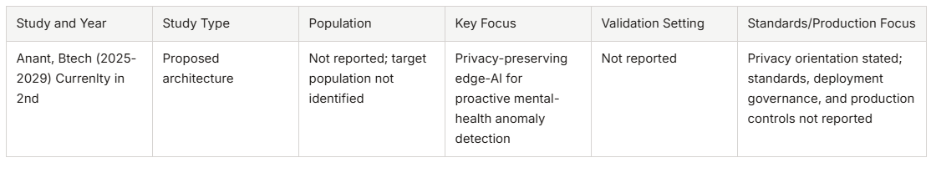
The included work is an architectural proposal rather than a validated performance study. It establishes the intended combination of edge computing, privacy preservation, and proactive mental-health anomaly detection, but does not provide sufficient information to evaluate implementation details, clinical applicability, technical effectiveness, or operational readiness (Anant, n.d.).
3.2 Thematic Findings
3.2.1 Edge Processing Is an Architectural Privacy Orientation, Not a Demonstrated Privacy Guarantee
Sentinel's central design claim is that mental-health anomaly detection should occur at or near the data source, potentially reducing wholesale transfer of sensitive data to centralized services (Anant, n.d.). This is potentially relevant to industry because minimizing raw-data movement can reduce centralized exposure and may support lower-latency inference. However, the available description does not establish whether processing is fully on-device, distributed across edge gateways, or coordinated with cloud services. Device types, data flows, storage locations, model-management functions, and transmission requirements are not reported.
The privacy model is therefore incomplete. There is no reported use of encryption, federated learning, differential privacy, consent management, data minimization, access controls, formal privacy guarantees, or documented threat model (Anant, n.d.). Edge deployment does not eliminate privacy risks: anomaly outputs, intermediate representations, model updates, logs, and device telemetry may still disclose sensitive information. Device compromise may also expose locally stored data or inference processes. Confidence: Limited, because the privacy-preserving direction is explicit, but its actual protections and assumptions are not specified.
3.2.2 Detection Effectiveness and Clinical Validity Cannot Be Established
Sentinel is intended to identify mental-health anomalies proactively, but the conditions, behavioral or physiological signals, anomaly definitions, target population, thresholds, and use context are not identified (Anant, n.d.). No dataset, sample size, baseline, outcome measure, sensitivity, specificity, false-positive rate, false-negative rate, calibration result, or clinical endpoint is reported. It is consequently impossible to determine whether the proposed system detects clinically meaningful deterioration, general behavioral variation, or an undefined computational anomaly.
The target population is also not reported. Note: this study examined a proposed architecture without an identified participant population, which partially matches the question population of users of proactive mental-health anomaly detection systems; findings should be interpreted considering this difference. This absence prevents assessment of demographic, cultural, socioeconomic, age-related, diagnostic, or accessibility-related performance differences. It also prevents assessment of whether alerts would be suitable for clinical decision-making or only for non-clinical wellness support. Confidence: Insufficient, because no empirical detection evidence is available.
3.2.3 Professional-Standard and Industry Readiness Are Unresolved
No clinical, security, machine-learning, software-engineering, interoperability, regulatory, oг responsible-Al standards are identified (Anant, n.d.). The absence of standards alignment is a direct professional limitation because mental-health systems require traceable requirements for safety, privacy, cybersecurity, validation, accountability, and human oversight. The available description does not indicate how Sentinel would address medical-device classification, health-data protection, secure development, auditability, informed consent, data retention, incident response, or algorithmic accountability.
Industry fit is similarly indeterminate. Device requirements, interoperability, scalability, model-update procedures, maintenance, monitoring, cybersecurity controls, clinical workflow integration, alert
governance regulatory classification and operational costs are not described (Anant) The architecture may be conceptually relevant to privacy-sensitive applications, but conceptual relevance is not equivalent to deployability. Confidence: Limited, because the identified gaps are clear, while the consequences for a specific deployment cannot be quantified without a defined implementation context.
3.2.4 Unresolved Safety, Governance, and Lifecycle Risks
The available description does not report failure analyses or explicit risk controls. Nevertheless, it identifies important unresolved issues for Sentinel's intended use, including false positives, false negatives, concept drift, ambiguous anomaly definitions, population bias, escalation procedures, human oversight, privacy leakage from outputs or updates, device compromise, and absent empirical validation (Anant, n.d.). These risks are interconnected. For example, a threshold selected without clinical validation may generate excessive alerts, while model drift may alter the meaning of the same signal over time. Without alert governance, even a technically accurate prediction does not specify who should review it, how urgently, or what intervention is justified.
The lifecycle problem is particularly important for edge systems because models may be distributed across heterogeneous devices and updated under inconsistent connectivity or security conditions. Yet Sentinel's update, rollback, monitoring, and incident-management processes are not reported. Confidence: Limited, reflecting clearly identifiable risk domains but no evidence about their observed frequency or severity.
3.3 Summary of Evidence
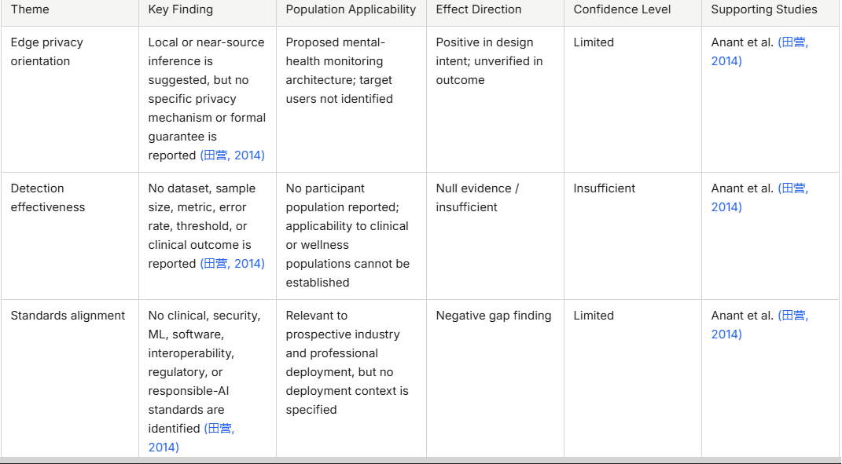
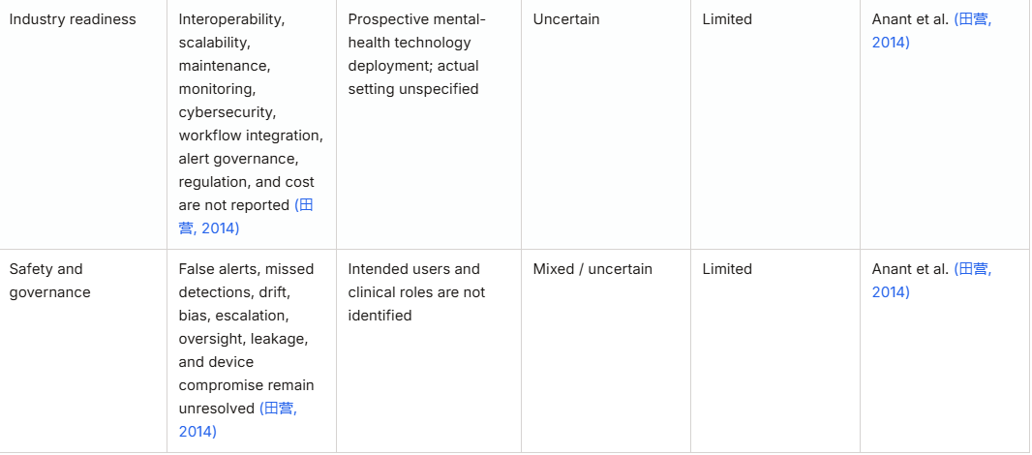

4. Discussion
4.1 Principal Findings and Their Interpretation
The most defensible interpretation is that Sentinel offers a privacy-oriented architectural proposition rather than an evidence-supported clinical or industrial system. Its edge-Al orientation is meaningful because reducing raw-data transfer can narrow one part of the exposure pathway between personal sensing and centralized services. However, privacy is a property of the complete information lifecycle, not merely of computation location. If outputs, updates, logs, or device states are transmitted or compromised, local inference may still permit sensitive inference. Because no threat model, formal privacy analysis, or implementation detail is reported, confidence in the privacy claim remains limited.
The absence of detection evidence is more consequential than a missing performance benchmark. Mental-health anomaly detection requires a defensible relationship between computational anomalies and clinically meaningful change. Sentinel does not identify the signals, conditions, population, threshold, or clinical decision that would establish this relationship (Anant, n.d.). As a result, it is not possible to infer whether the system would improve early support, increase unnecessary escalation, or fail to identify important deterioration. No mechanistic evidence is provided linking monitored behavioral or physiological markers to mental-health processes; this is a major gap rather than evidence that such mechanisms are absent.
The synthesis also reveals a distinction between architectural promise and professional readiness. Sentinel's design direction could support privacy-sensitive deployment, but the absence of standards alignment, lifecycle controls, workflow integration, and governance prevents translation into adeployable service. The strongest conclusion concerns documentation and evidence insufficiency: the architecture does not provide the information required for a reliable assessment of safety, effectiveness, or compliance. Conclusions about superior privacy, clinical benefit, or operational efficiency remain tentative because they are not supported by empirical comparisons or formal analyses.
4.2 Comparison with Existing Literature and Resolution of Contradictions
A conventional comparison with an established empirical literature is not possible from the available material because the source does not report comparisons with other architectures, prior models, clinical benchmarks, or professional frameworks. The apparent agreement between edge processing and privacy preservation is therefore conceptual rather than comparative. It is reasonable as an architectural hypothesis: keeping raw information closer to its source may reduce centralized data exposure. Nevertheless, the hypothesis cannot be treated as evidence of improved privacy without specifying what is transmitted, how it is protected, and which adversary is being considered.
There are no reported null or contradictory performance findings to resolve. Instead, the central uncertainty arises from missing evidence. The lack of reported validation could reflect an early conceptual stage, an incomplete description, or selective emphasis on architecture rather than evaluation; the available data cannot distinguish among these explanations. It could also conceal important heterogeneity, since undefined anomaly labels and populations make it impossible to know whether the system is intended for general wellness variation, diagnosed mental-health conditions, or acute clinical risk. These are not interchangeable use cases and would require different thresholds, error tolerances, escalation pathways, and evidence standards.
Publication bias cannot be estimated meaningfully from the available material. However, a proposal focused on privacy-preserving architecture may emphasize the benefits of edge computing while leaving implementation failures, privacy leakage, or alert burden unreported. This possibility reinforces
the need for preregistered evaluation, transparent reporting of negative results, and independent security and clinical review. No methodological evolution can be assessed because no temporal or comparative validation data are provided. The absence of contradiction should therefore not be interpreted as confirmation; it primarily indicates that Sentinel's claims remain empirically unresolved.
4.3 Practical Implications
For developers and technology providers, Sentinel's edge orientation is most relevant where raw mental-health data are highly sensitive and connectivity or centralized storage creates unacceptable exposure. Adoption would require an explicit data-flow map, threat model, encryption and access-control design, update and rollback procedures, device-security requirements, and monitoring for drift and compromise. These requirements apply particularly when inference outputs could trigger contact with clinicians, caregivers, employers, insurers, or emergency services. The source does not establish that Sentinel is ready for any of these contexts.
For clinicians, the architecture should not be treated as a validated diagnostic or triage system. Until target outcomes, error rates, thresholds, and escalation responsibilities are established, alerts would require qualified human review and should not independently determine diagnosis, treatment, or emergency intervention. Practitioners would also need clear information about what a detected "anomaly" means, since that term is not operationally defined.
For public-health and regulatory stakeholders, the principal implication is evidentiary: privacy-preserving computation does not substitute for clinical validation, cybersecurity assessment, accountability, or compliance documentation. Practical recommendations are therefore limited to requiring staged evaluation rather than endorsing deployment. Regulatory classification, applicable health-data obligations, interoperability expectations, and professional standards cannot be determined from the available description. No threshold or dose-response issue is relevant to the evidence presented, because Sentinel concerns algorithmic detection rather than an exposure relationship.
4.4 Strengths and Limitations
A strength of this review is its close alignment with the stated research question and its emphasis on industry and professional-standard limitations rather than treating architectural novelty as proof of effectiveness. The synthesis also distinguishes explicit design intent from demonstrated performance and identifies the specific information needed for deployment assessment.
The principal limitation is the very sparse evidence base and the absence of an abstract, empirical results, implementation details, validation data, standards references, and explicit limitation analysis in the available source material (Anant, n.d.). The target population is not identified, preventing population-match assessment beyond noting that the architecture is intended for mental-health monitoring. No formal risk-of-bias assessment, independent replication, or comparative evaluation is available. The review is also limited by its reference-manager scope, abstract-based and extracted-data-based screening, and incomplete reporting in the source record. Accordingly, the conclusions characterize evidence and readiness gaps rather than estimate system performance.
5. Gaps and Future Directions
The most immediate gap is the absence of a defined detection problem. Future studies should specify the mental-health conditions or behavioral states of interest, signals collected, anomaly labels, target population, alert thresholds, intended users, and clinical or wellness consequences. Because the current description identifies no participant population, direct evaluation should include representative users and report subgroup performance, calibration, false positives, false negatives, and clinically meaningful outcomes.
A second gap concerns privacy and security verification. Sentinel requires a documented end-to-end data-flow architecture, threat model, formal or empirically tested privacy analysis, device-compromiseassessment, protection of model updates, and evaluation of leakage through outputs and intermediate representations. Comparative testing should examine local inference against alternative deployment arrangements while reporting latency, energy, bandwidth, and operational costs.
Finally, future work should map the system to applicable clinical, cybersecurity, software-engineering, interoperability, regulatory, and responsible-Al requirements. Prospective or longitudinal deployment is needed to evaluate concept drift, maintenance, alert burden, human oversight, escalation, auditability, and integration with real workflows. Independent replication and transparent reporting of unsuccessful or unsafe outcomes are essential to distinguish architectural promise from dependable practice.
6. Conclusion
The available evidence supports only a limited conclusion: Sentinel is a promising privacy-oriented edge-Al concept, but its effectiveness, safety, professional-standard conformity, and industry readiness cannot currently be established. Processing mental-health information at or near its source may reduce wholesale centralized data transfer, yet no specific privacy mechanism, formal guarantee, threat model, or data-flow design is reported (Anant, n.d.). Likewise, no numerical detection results, clinical outcomes, target population, anomaly definition, alert threshold, or validation setting is available, so the architecture cannot be judged as an effective proactive mental-health detection system.
The principal industry and professional-standard problems are therefore evidentiary and governance-related. Sentinel does not identify alignment with clinical, security, machine-learning, software, interoperability, regulatory, or responsible-Al standards. Its production requirements-including device security, scalability, model maintenance, monitoring, workflow integration, alert governance, regulatory classification, and cost-are also not described (Anant, n.d.). Because no participant population is reported, the findings apply to a proposed architecture rather than to a defined clinical or wellness population.
The most important unresolved question is whether Sentinel can achieve clinically useful anomaly detection while preserving privacy under realistic device, adversarial, and workflow conditions. Answering that question will require transparent technical specifications, representative validation, formal privacy and cybersecurity analysis, lifecycle governance, and independent replication. Such evidence is necessary before edge-Al mental-health monitoring can move from an appealing privacy proposition toward responsible professional and industrial deployment.

References
Sentinel_Research_PaperV2 and V3.

